

Home Assignment:

Create, Update, and Delete Change Requests with Chaining Process in Postman
Learning Objective:
The objective of this session is to learn how to create, update, and delete change requests in ServiceNow using a chained process in Postman, and to save and reuse the sys_id from one request to the next.
Expected Completion Time:
- Best Case: 40 minutes
- Average Case: 50 minutes
Session Details:

ServiceNow API Credentials:
- Obtain Your ServiceNow Instance Credentials and set this in a collection level:
  - Instance URL , Username & Password

Creating, Updating, and Deleting Chnge Requests:

Part 1: Create a Change Request
Step 1: Create a new collection
- Create a collection for chaining of request.
- Set the Authorization as Collection Level.
- 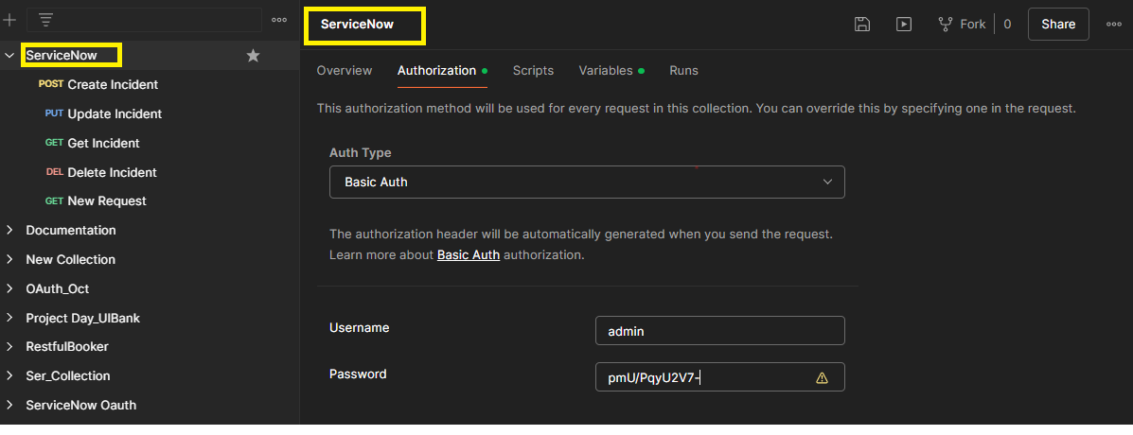
Step 2: Create a New Request
- Click on "New" and select "HTTP Request".
- Name your request appropriately, e.g., "Create Change Request".
Step 3: Set Up the Request URL
- Set the request type to POST.
- Enter the ServiceNow API endpoint for creating a change request:
POST https://<your_instance>.service-now.com/api/now/table/change_request
- Replace <your_instance> with your ServiceNow instance name.
Step 4: Authentication
- Go to the "Authorization" tab.
- Select "Inherit auth from Parent".
Step 5: Body
- Switch to the "Body" tab.
- Select raw and choose JSON from the drop-down menu.
- Enter the JSON payload for creating a change request. Example:
{
"short_description":"Chaininig of request",
"short_description":"Create Changerequest"
}
Step 6: Save the Response as a Variable
- Go to the "Tests" tab and add the following script to save the response as a variable:

var resp = pm.response.json();
var sysid = resp.result.sys_id;
pm.globals.set("cr_SysId", sysid);
pm.test("Status code is 201", function () {
pm.response.to.have.status(201);
});
Step 7: Send the Request
- Click "Send".
- Observe the response in the lower pane Body tab and ensure it contains the details of the newly created change request, including the sys_id.
- Check whether the Response code is 201.
- And Ensure the Test results.

Part 2: Read the Change Request
Step 1: Create a New Request
- Click on "New" and select "HTTP Request".
- Name your request appropriately, e.g., "Read Change Request".
Step 2: Set Up the Request URL
- Set the request type to GET.
- Enter the ServiceNow API endpoint for reading a change request:
GET https://<your_instance>.service-now.com/api/now/table/change_request/{{changeRequestSysId}}
- Replace <your_instance> with your ServiceNow instance name. The {{changeRequestSysId}} is the global variable set in the previous step.
Step 3: Authentication
- Go to the "Authorization" tab.
- Select "Inherit auth from Parent".
Step 5: Send the Request
- Click "Send".
- Observe the response in the lower pane Body tab to ensure it contains the details of the change request.
- Ensure the status code is 200 OK.

Part 3: Update the Change Request
Step 1: Create a New Request
- Click on "New" and select "HTTP Request".
- Name your request appropriately, e.g., "Update Change Request".
Step 2: Set Up the Request URL
- Set the request type to PUT.
- Enter the ServiceNow API endpoint for updating a change request:
PUT https://<your_instance>.service-now.com/api/now/table/change_request/{{changeRequestSysId}}
- Replace <your_instance> with your ServiceNow instance name. The {{changeRequestSysId}} is the global variable set in the POST Request.
Step 3: Authentication
- Go to the "Authorization" tab.
- Select "Inherit auth from Parent".
Step 4: Body
- Switch to the "Body" tab.
- Select raw and choose JSON from the drop-down menu.
- Enter the JSON payload for updating the change request. Example:
{
"short_description":"Chaining for change request ",
"short_description":"Update Request"
}

Step 5: Validate the Response body
pm.test("Body matches string", function () {
pm.expect(pm.response.text()).to.include("My laptop is Replaced");
});
- Add the snippet in Scripts Tab.
Step 5: Send the Request
- Click "Send".
- Observe the response in the lower pane Body Tab and ensure it contains the updated details of the change request.
- Ensure the status code is 200 and the Test results.

Part 4: Delete the Change Request
Step 1: Create a New Request
- Click on "New" and select "HTTP Request".
- Name your request appropriately, e.g., "Delete Change Request".
Step 2: Set Up the Request URL
- Set the request type to DELETE.
- Enter the ServiceNow API endpoint for deleting a change request:
DELETE https://<your_instance>.service-now.com/api/now/table/change_request/{{changeRequestSysId}}
- Replace <your_instance> with your ServiceNow instance name. The {{changeRequestSysId}} is the global variable set in the POST Request.
Step 3: Authentication
- Go to the "Authorization" tab.
- Select "Inherit auth from Parent".
Step 4: Send the Request
- Click "Send".
- Observe the response in the lower pane to ensure the change request has been successfully deleted.
- Check the Status code is 204 No content.

Expected Outcome:
Upon completion, you should be able to:
- Create a change request in ServiceNow via API and save the sys_id.
- Update the change request using the saved sys_id.
- Delete the change request using the saved sys_id.
- Understand how to chain requests in Postman by using variables.

